Steering committee on-line meeting
12 May 2020

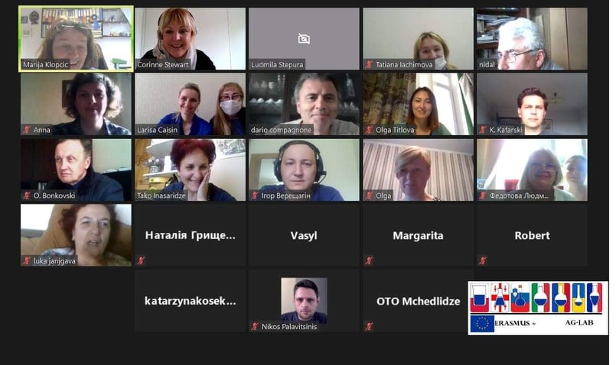
The meeting was devoted to the organization of the work of the project consortium in the conditions of the quarantine because of the pandemics caused by Covid 19, possible extension of the project and perspectives after the end of the quarantine.
Topics discussed at the meeting:
- Activities of the project consortium in the conditions of the quarantine.
Marija Klopcic, project coordinator summarized the results of the work packages leaders meeting hold on 9th of April. She presented the decisions taken at the meeting: to revise the work plan for the nearest period, to address to the European Commission the request for the project extension for 10 months, to create the advisory body for guarantying the project sustainability and to organize the on-line training session devoted to the innovative pedagogical tools applied in teaching issues related to the laboratory practice.
Olga Getya, SMC HPHE presented the developed work plan proposed to the consortium for the period of the quarantine until the 30th of June.

The Committee members actively participated in the discussion.

- Maintaining of the Moodle platform
Nikos Palavintinis, ISLE, presented the Moodle platform used by the project partners for publishing the training courses followed by tests and other relevant elements. He demonstrated the Template for new courses containing announcement, glossary, knowledge to attend, the example of quiz to check the obtained knowledge etc.

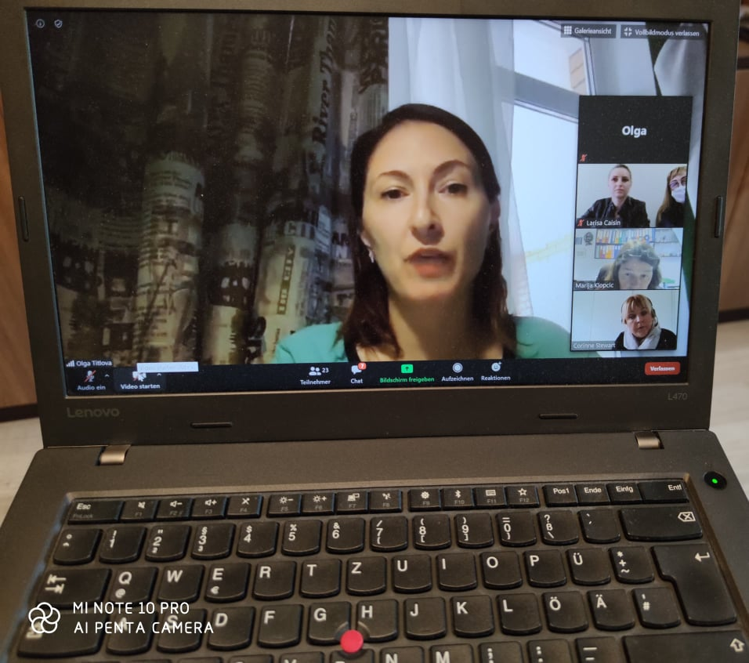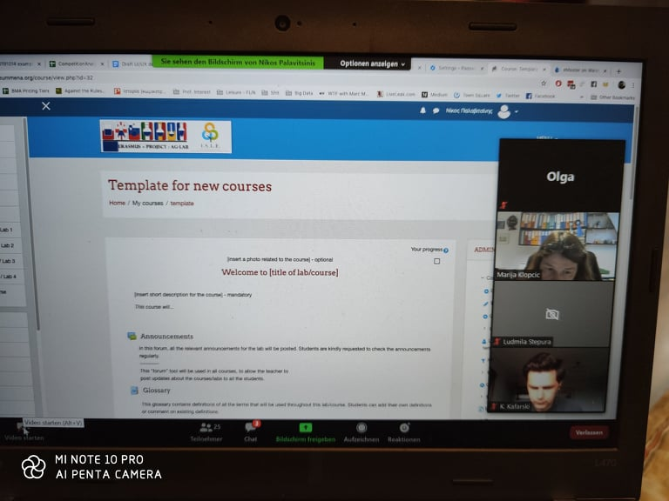

- Dissemination and the Sustainability strategy
Corinne Stewart, ISLE, presented the elaborated Excel document summarizing all dissemination activities of the project partners since its beginning and invited the partners to complete it in case of some missing information or some new activities. In order to ensure the project sustainability, the “"Coalition Board" should be set-up. It will comprise members from different Stakeholders to ensure that sustainability is addressed throughout the remaining phases of the project.
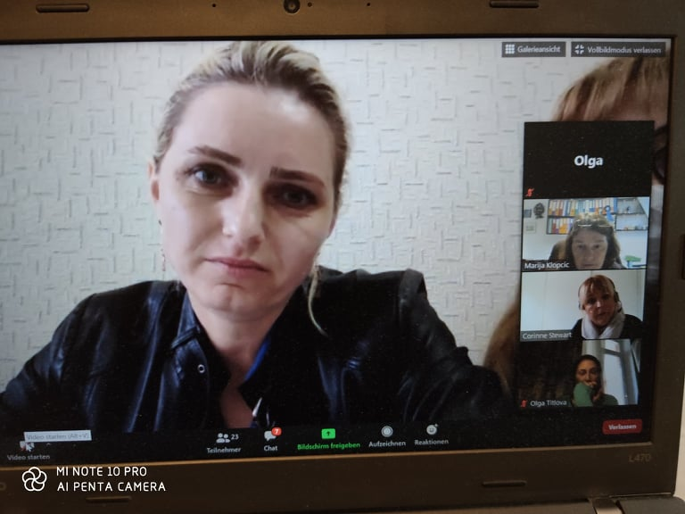
Stepura Ludmila, SMC HPHE, made the review of the activities foreseen for the period of November 2019 – April 2020. Some of these activities were realized partially, some were not realized because of the quarantine. That is why the following activities should be launched just after the end of the quarantine: the students mobility between UA, GE and MD, the training session at UL together with the next steering committee meeting, common action organized between universities and laboratories in UA, GE and MD.
Discussion:
The following decisions were taken:
- To follow the proposed plan for the period April – June 2020;
- To organize the webinar devoted to innovative pedagogical tools animated by UniTe;
- To consider the possibility of organizing one or two more webinars according the proposals received from the partners;
- To create the editorial bodies for every chapter of the Manual for its final proof reading; to collect the names of authors for every chapter of the Manual.
- To organize the separate meetings with UA, MD and GE partners for organizing and improving their activities as for the Moodle platform development
- To provide the proposal of the candidates to the Coalition Body from every partner country
- To develop and to complete the questionnaire to make a survey concerning institutions response to COVID-19.
- To follow the proposed Work plan after the end of the quarantine.

